台北市選情觀測站

Voice of share on candidates of Taipei city mayor election

看誰最大聲?

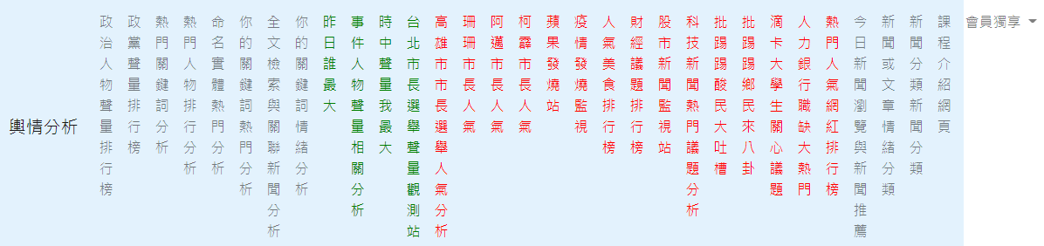

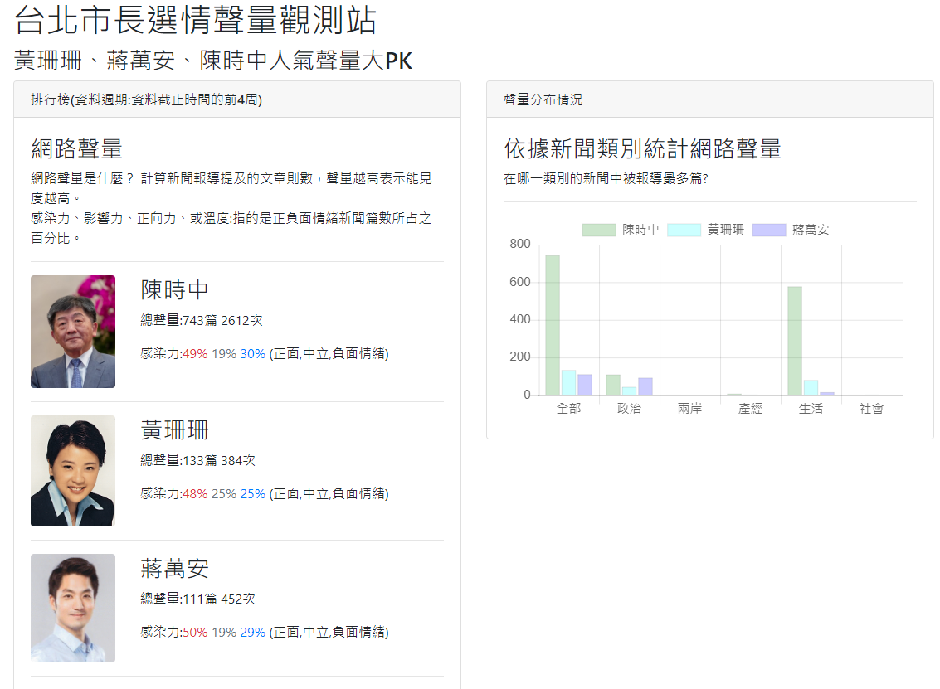

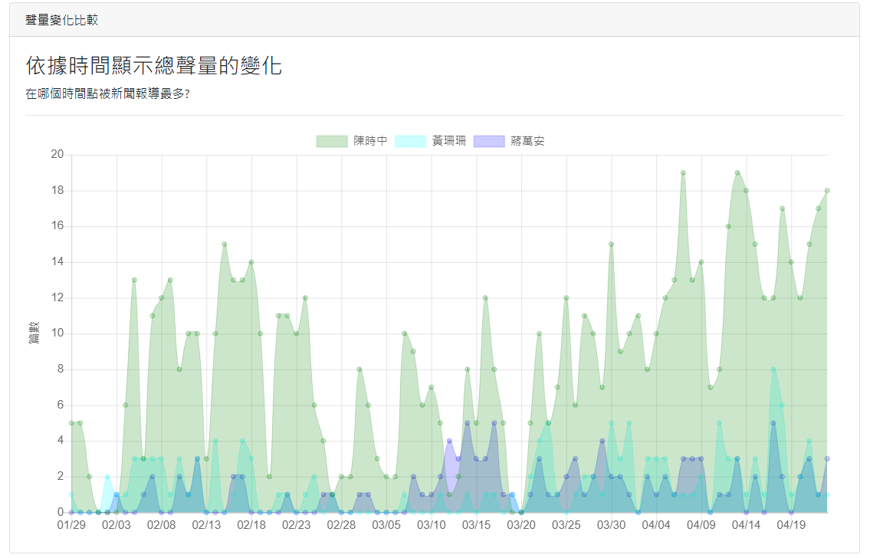

請參看範例程式碼。

Main steps

Project name:

website-news-analysis-feature-apps

>django-admin startproject website_configs .

App name:

app_taipei_mayor

>django-admin startapp app_taipei_mayor

Api in views.py:

api_get_taipei_mayor_data

website_configs/urls.py

For app_taipe_mayor:

views.py

urls.py

home.html 🡪 This is the most difficult part.

settings.py

|  |
| --- |
| # Application definition  INSTALLED_APPS = [  'django.contrib.admin',  'django.contrib.auth',  'django.contrib.contenttypes',  'django.contrib.sessions',  'django.contrib.messages',  'django.contrib.staticfiles',  #'corsheaders', # 跨域資源共享  #'app_top_person_yesterday',  #'app_scchen',  #'app_correlation',  'app_taipei_mayor',  ]  ALLOWED_HOSTS = ['*']  import os  'DIRS': [os.path.join(BASE_DIR, 'templates')], |

websit_configs/urls.py

|  |
| --- |
| from django.contrib import admin  from django.urls import path  from django.urls import include  urlpatterns = [  # app who is the most popular yesterday  #path('', include('app_top_person_yesterday.urls')),  #path('toppersonYesterday/', include('app_top_person_yesterday.urls')),    # app shih chung chen  #path('scchen/', include('app_scchen.urls')),  # correlation  #path('correlation/', include('app_correlation.urls')),    # taipei mayor election  # path('taipeimayor/', include('app_taipei_mayor.urls')),  path('', include('app_taipei_mayor.urls')),    ] |

urls.py

|  |
| --- |
| from django.urls import path  from app_taipei_mayor import views  app_name='namespace_taipei_mayor'  urlpatterns = [  path('', views.home, name='home'),  path('api_get_taipei_mayor_data/', views.api_get_taipei_mayor_data),  ] |

views.py

|  |
| --- |
| from django.http import JsonResponse  import pandas as pd  from django.shortcuts import render  from django.views.decorators.csrf import csrf_exempt  def load_data_pk():  # Read data from csv file  df_data_pk = pd.read_csv('app_taipei_mayor/dataset/pk_taipei_mayor_election.csv')    global data  data={}  for k,v in zip(df_data_pk.name, df_data_pk.value):  data[k]=eval(v)    # 沒用到的變數刪除之  del df_data_pk  # load pk data  load_data_pk()  def home(request):  return render(request,'app_taipei_mayor/home.html')  # csrf_exempt is used for POST  # 單獨指定這一支程式忽略csrf驗證  @csrf_exempt  def api_get_taipei_mayor_data(request):  return JsonResponse(data)  print('Load app taipei mayor leaderboard...') |

base.html

|  |
| --- |
| href="{% url 'app_taipei_mayor:home' %}" |

home.html

Please find the handout home.html.

|  |
| --- |
|  |